Project Design Phase-II TechnologyStack(Architecture&Stack)

|  |  |
| --- | --- |
| Date | 3 July 2025 |
| Team ID | LTVIP2025TMID60948 |
| ProjectName | Measuringthepulseofprosperity:anindexof economic freedom |
| MaximumMarks | 4 Marks |

TechnicalArchitecture:

TheDeliverableshallincludethearchitecturaldiagramasbelowandtheinformationasperthetable1&table2

Reference:<https://developer.ibm.com/patterns/ai-powered-backend-system-for-order-processing-during-pandemics/>

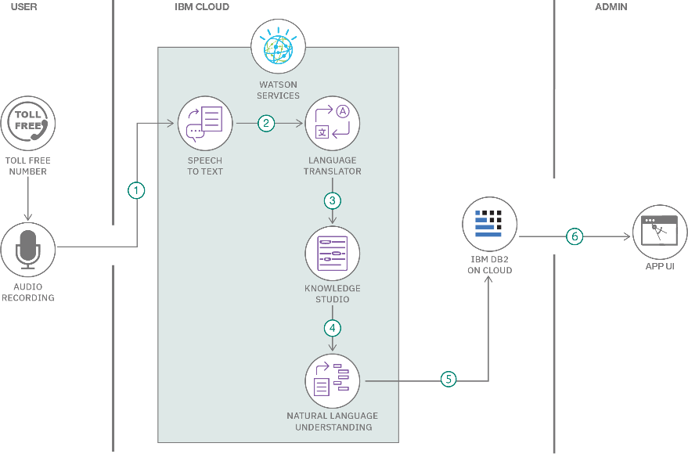

Table-1:Components&Technologies:

|  |  |  |  |
| --- | --- | --- | --- |
| **S.No** | **Component** | **Description** | **Technology** |
| 1. | UserInterface | Webinterfacefordatavisualization&interaction | HTML,CSS,JavaScript,Plotly.js |
| 2. | ApplicationLogic-1 | Datapreprocessingandnormalization | Python |
| 3. | ApplicationLogic-2 | Correlationanalysisbetweeneconomicindexand indicators | Python(SciPy,statsmodels) |
| 4. | ApplicationLogic-3 | Interactivedashboardgeneration | Streamlit/Flask/Dash |
| 5. | Database | Storerawandprocesseddata | MySQL |
| 6. | CloudDatabase | Hostforshared/real-timeaccess | Firebase |
| 7. | FileStorage | Uploadandmanagedatasets(CSV, Excel) | LocalFilesystem |
| 8. | ExternalAPI-1 | Pulladditionaleconomicdata | WorldBank API, |
| 9. | ExternalAPI-2 | Geomappingorvisualizationservices | GoogleMapsAPI. |
| 10. | MachineLearningModel | Predictprosperitybasedoneconomicindicators | Scikit-learnRegressionModel |
| 11. | Infrastructure(Server/Cloud) | Hostinganddeployment | Local. |

Table-2:ApplicationCharacteristics:

|  |  |  |  |
| --- | --- | --- | --- |
| **S.No** | **Characteristics** | **Description** | **Technology** |
| 1. | Open-SourceFrameworks | Frameworksusedforvisualizationandapp deployment | Streamlit,Plotly,Dash,Pandas |
| 2. | SecurityImplementations | Basicinputvalidation,roleaccess,andsecure upload | SSL,SHA-256hashing,FirebaseAuth |
| 3. | ScalableArchitecture | Modular,scalablewithcloudhosting&stateless APIs | Microservicesarchitectureon Flask/Streamlit |
| 4. | Availability | Cloud-hostedwithminimaldowntime | AWSEC2,FirebaseHosting,Streamlit Cloud |
| 5. | Performance | Optimizedthroughcachingandminimalpayload visualization for fast loading | JSONqueries |

References:

<https://c4model.com/>

<https://developer.ibm.com/patterns/online-order-processing-system-during-pandemic/><https://www.ibm.com/cloud/architecture>

<https://aws.amazon.com/architecture>

<https://medium.com/the-internal-startup/how-to-draw-useful-technical-architecture-diagrams-2d20c9fda90d>